Shane Riegodedios

Dr. Amtoft

CIS 575: Intro to Algorithm Analysis

February 14, 2017

1.)

$T\left(n\right)=4T\left(\frac{n}{2}\right)+n^{2} a=4, b=2, r= \log_{2}^{ }4$

$f\left(n\right)= n^{2} ∈\left(n^{2}lgn\right) → T\left(n\right)∈ ∅(n^{2}lgn)$

$T\left(n\right)=4T\left(\frac{n}{2}\right)+N a=4, b=2, r= \log_{2}^{ }4$

$T\left(n\right)∈ ∅(n^{2})$

$T\left(n\right)=T\left(n+1\right)+ n^{2} a=1, b=1, r= \log_{1}^{ }1$

$T\left(n\right)∈ ∅(n^{2})$

2.)

1.) $T\left(\frac{n}{2}\right)+3$

2.) $T\left(n\right)∈ ∅(\lg\left(n\right))$

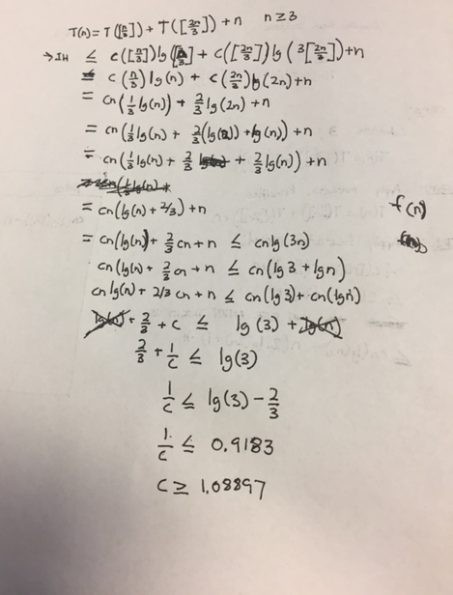

3.)